**Directions on How to Join a Teams Call**

1. [Click here to join the meeting](https://teams.microsoft.com/l/meetup-join/19:meeting_OGVhYzVjMTAtMjdkZi00OTQyLWE4ZmMtNGMxZGYyNTVhMTkz@thread.v2/0?context=%7B%22Tid%22:%22a9dab8fb-3882-4536-baf4-e11792645dbb%22,%22Oid%22:%223a882d65-4c03-45d1-83fa-4c51df6fa777%22%7D%22%20%5Ct%20%22_blank) – you may have the option to just sign in as a “guest”, which would allow you to skip to step #4.
2. Select “Continue on this browser” and choose *cancel* in the black box that pops up.



1. 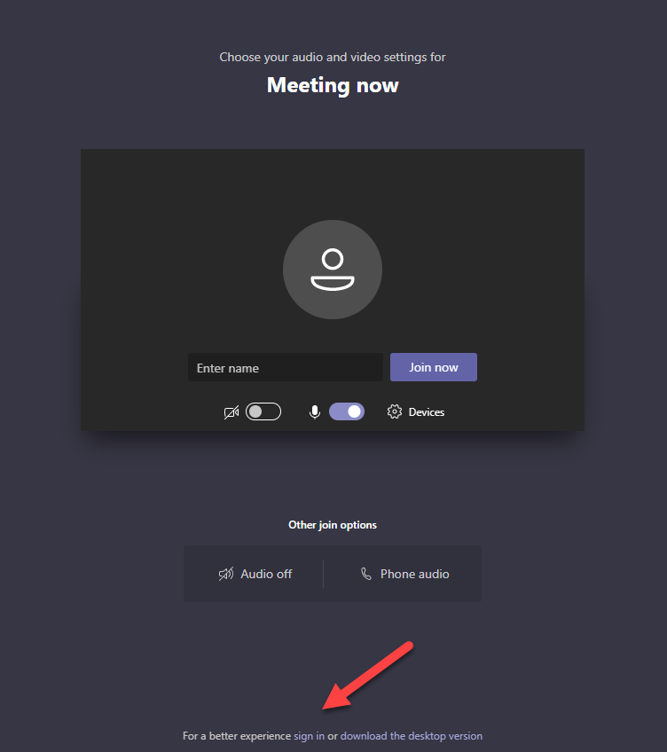Sign into Microsoft using your email address or phone number if you have used Microsoft in the past. If you have not, you will need to create a free account.   
   

1. Enter your name in the box and click “Join Now” 🡪