GOING TO A THERAPY APPOINTMENT
I have to wear a mask to my appointment. | 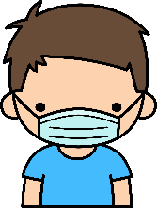
I have to use hand sanitizer after touching door knobs and handrails. | 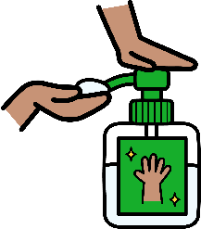
When I get to the appointment, someone may check to see if I have a fever.

While at my appointment, I have to keep space between myself and other people. | 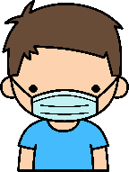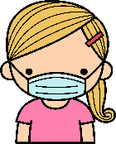
I have to use hand sanitizer or wash my hands after leaving my appointment. | 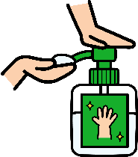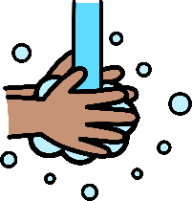
I have to wear my mask until a grown-up says I can take it off. | 