Setting Screen Time & Content Restrictions on Apple Devices

- The settings for Screen Time & Content Restrictions are found in the Settings app.
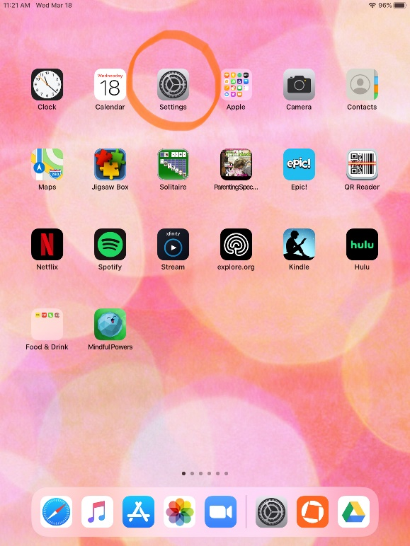

- Screen Time is found on the left side of the menu in Settings. Click on “Turn on Screen Time”. Even if you don’t want to set screen time limits, all of the content restriction settings are found here too.
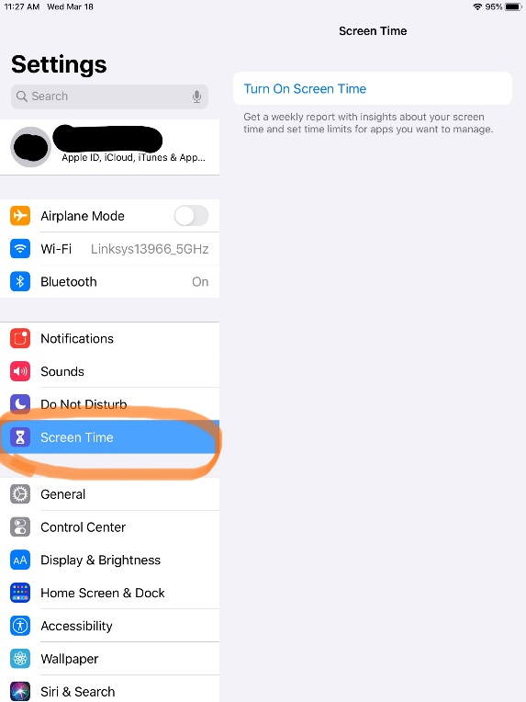
- The first time you open screen time, it will explain the features…

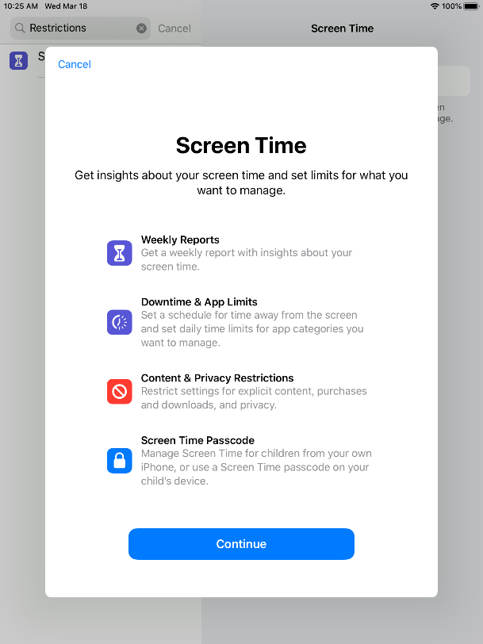

- Then walk you through the set-up process.

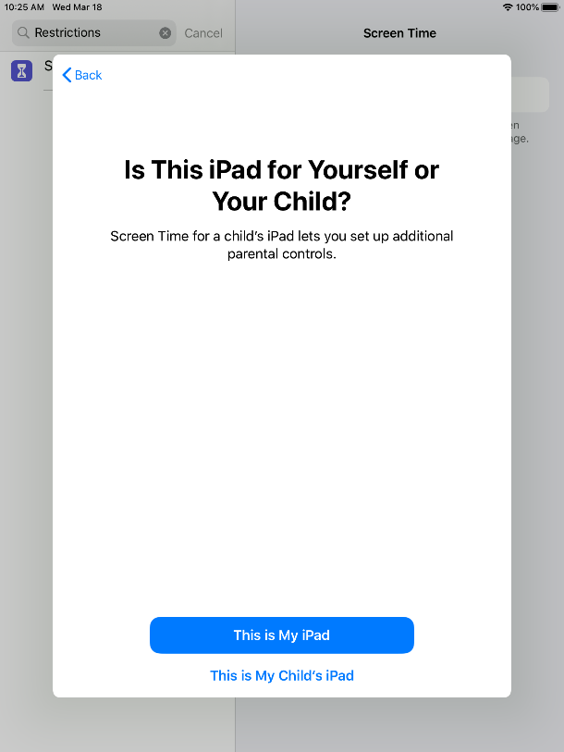

- “Downtime” allows you to choose times when your child will not be allowed to access the iPad or iPhone. You can choose to still allow messages, calls, or other apps during this time.
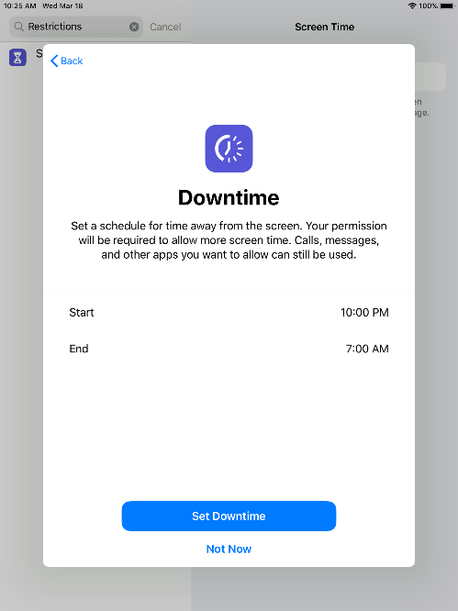

- “App Limits” can be set for an entire category or for only particular apps. You can decide, for example, that your child can only access “social networking” apps for 1 hour per day.
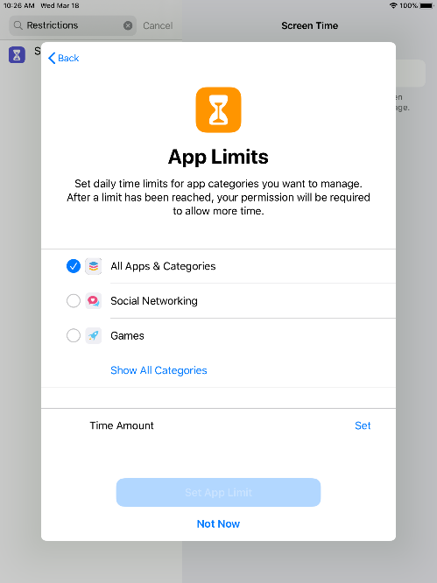

- This screen will introduce you to the features to restrict content & privacy settings. You can choose the highest rating of a movie that your child is allowed to watch, for example.
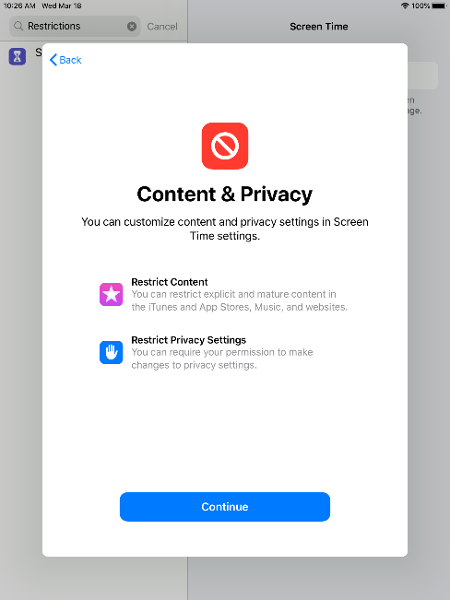

- Create a screen time passcode (different from the passcode that controls the whole device). This is important so that your child cannot access the settings and change them.
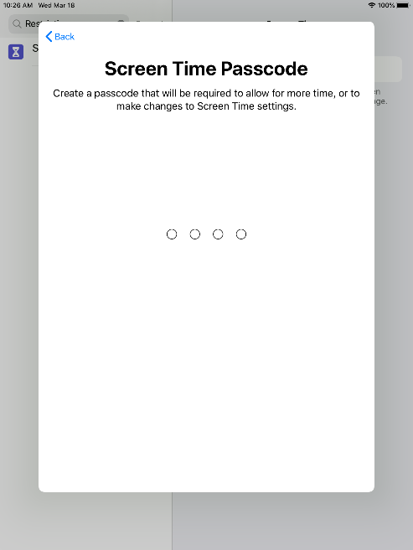

- After you create the screen time passcode, there is an option to use your Apple ID to recover the passcode in case you forget it.

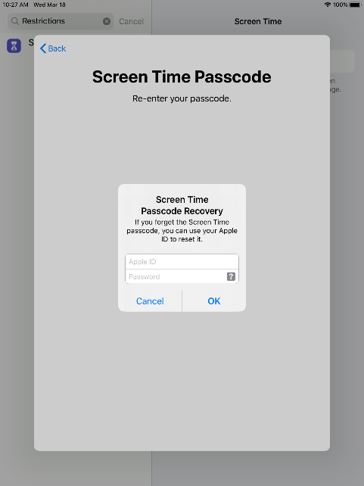

- When you see this screen (after setting up your passcode), choose “content & privacy restrictions” to begin choosing the appropriate settings for your child.

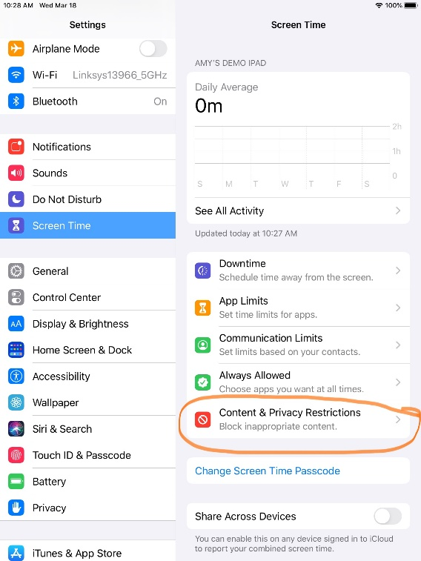

- You must first toggle the “content & privacy restrictions” button to allow access to the individual settings. Then click on “content restriction”

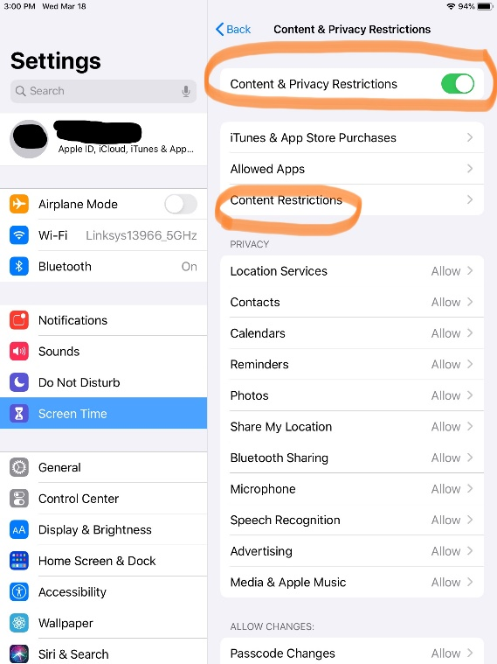

- In “content restrictions”, you can choose the ratings for music, movies, tv shows, etc.

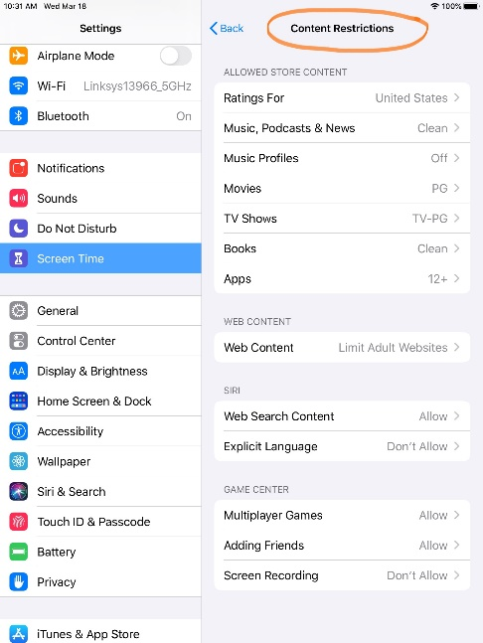

- Below “content & privacy” options, you also have “privacy” and “allow changes”. These refer to public sharing of location, etc. and also what changes your child is allowed to make to the device (passwords, etc.). This can be very helpful if the device is being used by a small child who may accidentally make changes or to one that is super savvy and may want to make changes!
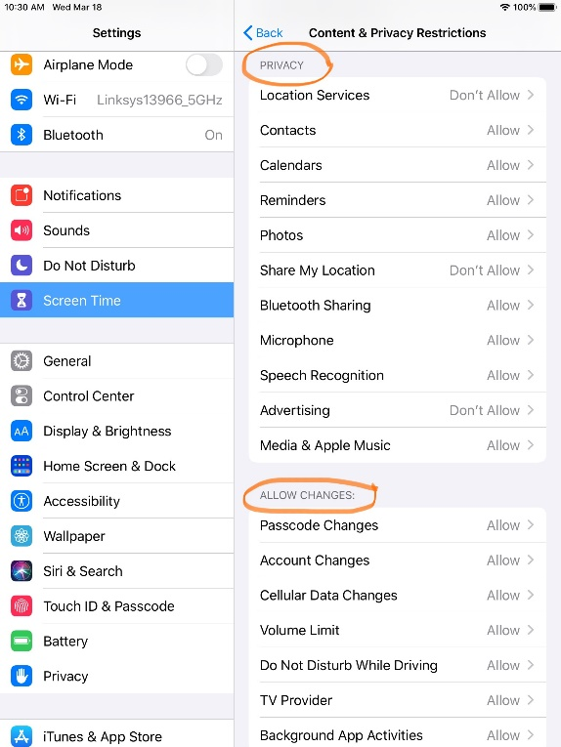

- The bottom right part of the screen time menu allows you to share the settings you have chosen across devices or set up for your family. It also provides an easy way to turn off screen time temporarily if needed.
